Wireframe As of 4/21/19:

The new website is comprised of 4 main webpages for the “Welcome” page, “Database” schema page, example “Analysis #1”, and example “Analysis #2”.

Users are also able to add dynamic webpages using the “Add New Query”, and draw their own conclusions by writing MySQL statements and reviewing the graphical interpretations of their own analysis.

Current Welcome Page:


Database Page:

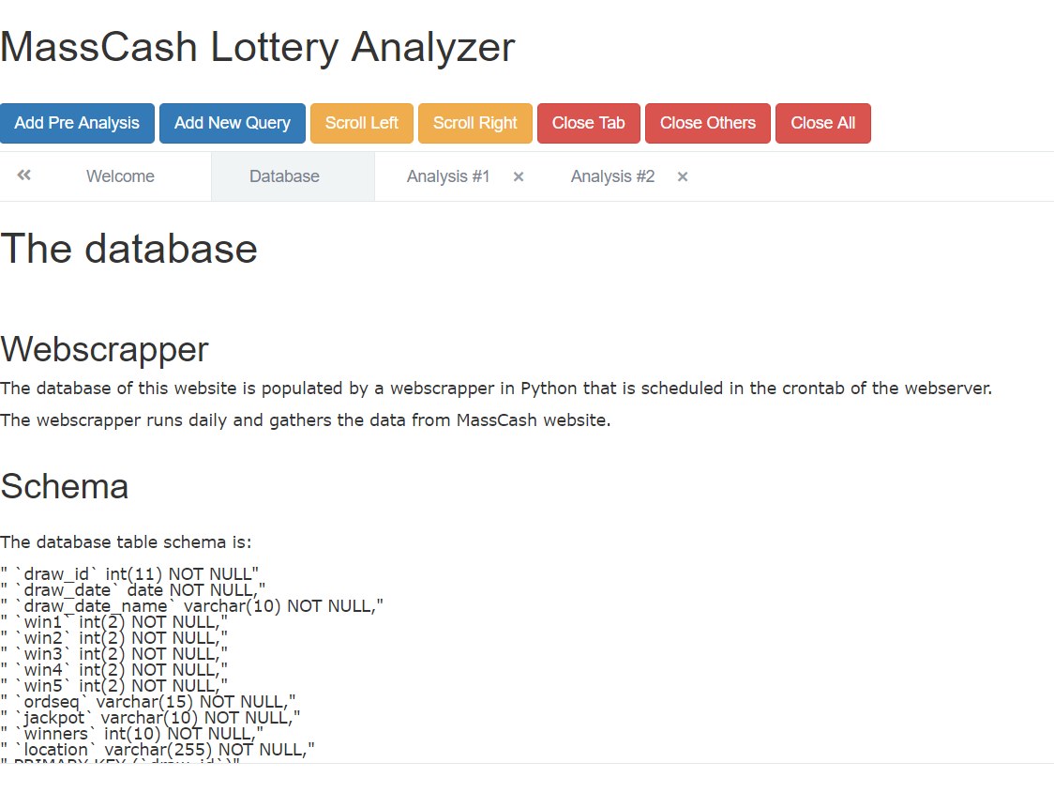
Analysis #1:

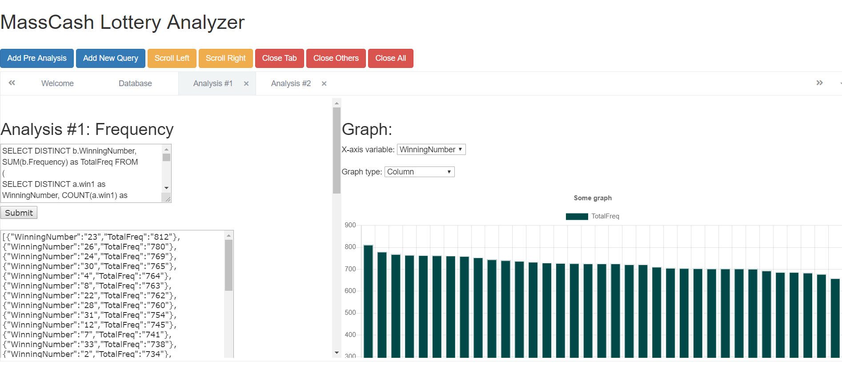

Analysis #2:

